

HOME APPLICATION CONTROL

Introduction to embedded systems project



December 25, 2024

**Team members**

|  |  |
| --- | --- |
| Malak Mohamed Salem | 21P0277 |
| Mariam Mahmoud Abdou | 21P0214 |
| Siveen Said Sayed | 21P0149 |
| Hager Hesham Mohamed | 21P0297 |
| Hamsa Ahmad Abdlmgeed | 20P1874 |

# **Project Overview**

The Home Appliances Control System is a comprehensive solution that enables users to monitor and control various home appliances through a mobile application. The system implements a layered architecture approach, consisting of three main layers:

## 1. Application Layer (main)

- Android mobile application providing user interface for control and monitoring

- Handles user interactions and displays system status

- Implements temperature alarm logic and door status logging

- Manages Bluetooth communication with the microcontroller

## 2. Hardware Abstraction Layer (HAL)

(magnetic_switch.c/h, temp.c/h, lamp_plug.c/h, bluetooth_module.c/h)

- Provides abstract interface between hardware and middleware

- Implements device drivers for:

- Lamp and plug switches

- Temperature sensor

- Magnetic door switch

- Bluetooth module

- Physical alarm

- Handles hardware initialization and configuration

## 3. Middleware/Mechanical Layer

( tm4c123gh6pm.h, DIO.c/h, adc.c/h, uart.c/h , Systick.c/h, utils.h )

- Implements control logic for appliance switching

- Initializes ports and pins

- Manages state transitions and system timing

# **System Architecture Overview**

The system utilizes a TM4C123GH6PM microcontroller as its core processing unit, interfacing with various peripheral devices and sensors.

# **Hardware Implementation**

## Core Components:

### 1. Processing Unit

- TM4C123GH6PM microcontroller

- Operating at 16MHz

- Utilizing GPIO, ADC, and UART peripherals

### 2. Power Management

- 5V DC power supply for microcontroller and sensors

- 220V AC handling through isolated relay modules

- Voltage regulation and protection circuits

### 3. Sensing Elements

- Temperature sensor for room monitoring

- Magnetic reed switch for door status detection

### 4. Control Elements

- Switches for lamp and plug control

### 5. Communication

- Bluetooth module for mobile app connectivity

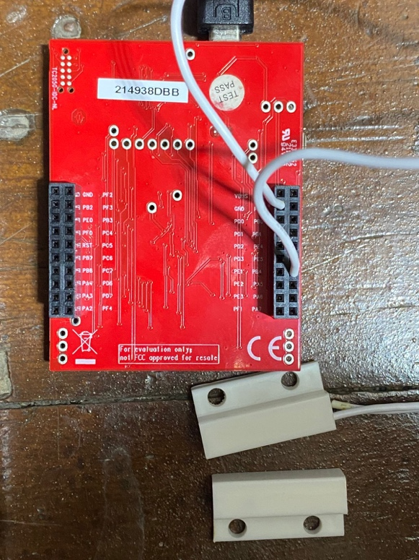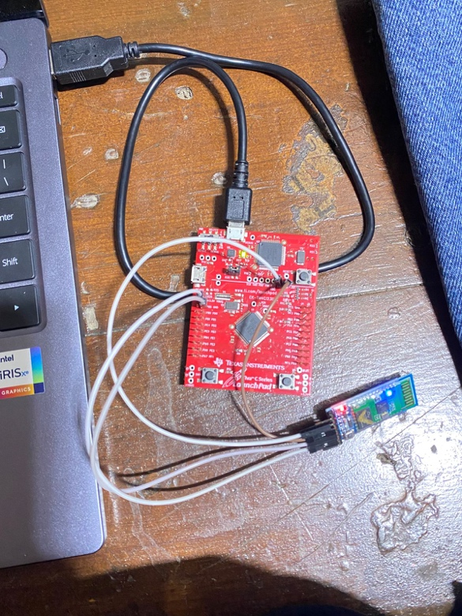

# **Software Architecture**

## Android Application Structure

- User interface for appliance control

- Real-time temperature monitoring

- Door status logging system

- Bluetooth communication handler

- Alarm for high temperature detection

- Switches for controlling lamp and plug remotely.

## Microcontroller Firmware

- Main control loop

- Interrupt handlers

- Serial communication implementation

# **Software Implementation Details**

## Driver Layer Implementation

### 1. Utility file (utils.h)

The system implements fundamental bitwise operations through macro definitions, These operations form the foundation for all hardware interactions in the system.

- **SET_BIT:** Sets a specific bit in a register

**- CLEAR_BIT:** Clears a specific bit in a register

**- TOGGLE_BIT:** Toggles a specific bit in a register

**- GET_BIT:** Reads the value of a specific bit

**- WRITE_BYTE:** Writes a complete byte to a register

#ifndef BITWISE_OPERATIONS_H

#define BITWISE_OPERATIONS_H

#define SET_BIT(REG, BIT) ((REG) |= (1U << (BIT)))

#define CLEAR_BIT(REG, BIT) ((REG) &= ~(1U << (BIT)))

#define TOGGLE_BIT(REG, BIT) ((REG) ^= (1U << (BIT)))

#define GET_BIT(REG, BIT) (((REG) >> (BIT)) & 1U)

#define WRITE_BYTE(REG, VALUE) ((REG) = VALUE))

#endif // BITWISE_OPERATIONS_H

## 2. Digital I/O Module (DIO)

The DIO module provides a hardware abstraction layer for **GPIO** operations:

**Key Features:**

- Port initialization and configuration

- Pin direction control (INPUT/OUTPUT)

- Digital/Analog mode selection

- Pull-up/Pull-down configuration

- Port and pin-level read/write operations

**Implementation Highlights:**

#include "DIO.h"

/**

* Function to get the base address of the specified port.

* port: The port identifier (e.g., PORT_A, PORT_B, etc.).

* return: The base address of the GPIO port, or 0xFF if the port is invalid.

*/

uint32_t get_port_base(uint8_t port) {

switch (port) {

case PORT_A: return GPIO_PORTA_BASE;

case PORT_B: return GPIO_PORTB_BASE;

case PORT_C: return GPIO_PORTC_BASE;

case PORT_D: return GPIO_PORTD_BASE;

case PORT_E: return GPIO_PORTE_BASE;

case PORT_F: return GPIO_PORTF_BASE;

default: return 0xFF; // Invalid port identifier

}

}

/**

* Function to initialize a GPIO pin.

* port: The port identifier (e.g., PORT_A).

* pin: The pin number within the port (0-7).

* direction: The pin direction (1 for output, 0 for input).

* mode: The mode of the pin (1 for digital, 0 for analog).

*/

void dio_init(uint8_t port, uint8_t pin, uint8_t direction, uint8_t mode) {

uint32_t port_base = get_port_base(port);

if (port_base == 0xFF) return; // Exit if the port is invalid

// Enable the clock for the specified port

SET_BIT(SYSCTL_RCGCGPIO_R, port);

while (GET_BIT(SYSCTL_PRGPIO_R, port) == 0); // Wait until the port is ready

// Unlock mechanism for locked pins

GPIO_PORT_LOCK_R(port_base) = GPIO_LOCK_KEY; // Unlock the port using the key

SET_BIT(GPIO_PORT_CR_R(port_base), pin); // Allow changes to the pin configuration

// Set the pin direction (input or output)

if (direction)

SET_BIT(GPIO_PORT_DIR_R(port_base), pin); // Configure as output

else

CLEAR_BIT(GPIO_PORT_DIR_R(port_base), pin); // Configure as input

// Configure the pin mode (digital or analog)

if (mode)

SET_BIT(GPIO_PORT_DEN_R(port_base), pin); // Enable digital functionality

else

CLEAR_BIT(GPIO_PORT_DEN_R(port_base), pin); // Enable analog functionality

}

/**

* Function to configure the internal pull-up resistor for a pin.

* port: The port identifier (e.g., PORT_A).

* pin: The pin number within the port (0-7).

* pull: Enable or disable pull-up (1 to enable, 0 to disable).

*/

void dio_pull(uint8_t port, uint8_t pin, uint8_t pull) {

uint32_t port_base = get_port_base(port);

if (port_base == 0xFF) return; // Exit if the port is invalid

if (pull)

SET_BIT(GPIO_PORT_PUR_R(port_base), pin); // Enable pull-up resistor

else

CLEAR_BIT(GPIO_PORT_PUR_R(port_base), pin); // Disable pull-up resistor

}

/**

* Function to read the value of a specific pin.

* port: The port identifier (e.g., PORT_A).

* pin: The pin number within the port (0-7).

* return: The value of the pin (1 for high, 0 for low, or 0xFF if invalid).

*/

uint8_t dio_readpin(uint8_t port, uint8_t pin) {

uint32_t port_base = get_port_base(port);

if (port_base == 0xFF) return 0xFF; // Return 0xFF for invalid port

return GET_BIT(GPIO_PORT_DATA_R(port_base), pin); // Read and return pin value

}

/**

* Function to read the value of an entire port.

* port: The port identifier (e.g., PORT_A).

* return: The value of the port (8-bit), or 0xFF if invalid.

*/

uint8_t dio_readport(uint8_t port) {

uint32_t port_base = get_port_base(port);

if (port_base == 0xFF) return 0xFF; // Return 0xFF for invalid port

return (uint8_t)GPIO_PORT_DATA_R(port_base); // Read and return port value

}

/**

* Function to write a value to a specific pin.

* port: The port identifier (e.g., PORT_A).

* pin: The pin number within the port (0-7).

* value: The value to write (1 for high, 0 for low).

*/

void dio_writepin(uint8_t port, uint8_t pin, uint8_t value) {

uint32_t port_base = get_port_base(port);

if (port_base == 0xFF) return; // Exit if the port is invalid

if (value)

SET_BIT(GPIO_PORT_DATA_R(port_base), pin); // Set pin high

else

CLEAR_BIT(GPIO_PORT_DATA_R(port_base), pin); // Set pin low

}

/**

* Function to write a value to an entire port.

* port: The port identifier (e.g., PORT_A).

* value: The 8-bit value to write to the port.

*/

void dio_writeport(uint8_t port, uint8_t value) {

uint32_t port_base = get_port_base(port);

if (port_base == 0xFF) return; // Exit if the port is invalid

GPIO_PORT_DATA_R(port_base) = value; // Write the value to the entire port

}

## Hardware Abstraction Layer (HAL)

### Magnetic Switch Implementation:

#include "magnetic_switch.h"

// Pointer to the interrupt callback function

static void (*interrupt_callback)(void) = 0; // Callback function for the interrupt

// Global variables to store the port and pin configuration

static uint8_t g_port;

static uint8_t g_pin;

/**

* Initialize the magnetic switch with the given port and pin.

* Configures the pin as an input with a pull-up resistor and sets up the interrupt.

* port: The GPIO port identifier (PORT_B).

* pin: The pin number within the port (4).

* callback: Pointer to the callback function to execute on interrupt.

*/

void magnetic_switch_init(uint8_t port, uint8_t pin, void (*callback)(void)) {

uint32_t port_base = get_port_base(port);

if (port_base == 0xFF) return; // Exit if the port is invalid

// Initialize the pin as input with pull-up resistor

dio_init(port, pin, IN, DIGITAL);

dio_pull(port, pin, UP);

// Store global interrupt configuration

g_port = port;

g_pin = pin;

// Configure GPIO interrupt settings

CLEAR_BIT(GPIO_PORT_IM_R(port_base), pin); // Disable interrupt for the pin during setup

CLEAR_BIT(GPIO_PORT_IS_R(port_base), pin); // Set to edge-sensitive interrupt

SET_BIT(GPIO_PORT_IBE_R(port_base), pin); // Enable interrupt on both edges (rising and falling)

SET_BIT(GPIO_PORT_ICR_R(port_base), pin); // Clear any prior interrupt flags

SET_BIT(GPIO_PORT_IM_R(port_base), pin); // Enable interrupt for the pin

// Enable the corresponding NVIC interrupt for the port

switch (port) {

case PORT_A: SET_BIT(NVIC_EN0_R, 0); break;

case PORT_B: SET_BIT(NVIC_EN0_R, 1); break;

case PORT_C: SET_BIT(NVIC_EN0_R, 2); break;

case PORT_D: SET_BIT(NVIC_EN0_R, 3); break;

case PORT_E: SET_BIT(NVIC_EN0_R, 4); break;

case PORT_F: SET_BIT(NVIC_EN0_R, 30); break;

}

// Assign the user-defined callback function

interrupt_callback = callback;

}

/**

* Get the current state of the magnetic switch.

* port: The GPIO port identifier (e.g., PORT_A).

* pin: The pin number within the port (0-7).

*return: The current state of the pin (1 for high, 0 for low, or 0xFF if invalid).

*/

uint8_t get_magnetic_switch_state(uint8_t port, uint8_t pin) {

uint32_t port_base = get_port_base(port);

if (port_base == 0xFF) return 0xFF; // Return 0xFF for invalid port

return dio_readpin(port, pin); // Return the current state of the pin

}

/**

* Interrupt Service Routine (ISR) for the magnetic switch.

* Handles the GPIO interrupt, clears the interrupt flag, and calls the user-defined callback function.

*/

void magnetic_switch_handler(void) {

// Clear the interrupt flag for the specific pin

uint32_t port_base = get_port_base(g_port);

if (port_base == 0xFF) return; // Exit if port_base is invalid

SET_BIT(GPIO_PORT_ICR_R(port_base), g_pin); // Clear the interrupt flag

// Execute the callback function if defined

if (interrupt_callback != 0) {

interrupt_callback(); // Call the user-defined interrupt handler

}

}

**Key Features:**

- Interrupt-driven door state detection

- Callback mechanism for state changes

- Built-in debouncing through hardware configuration

- Real-time status reporting through Bluetooth

### Temperature and Buzzer Implementation:

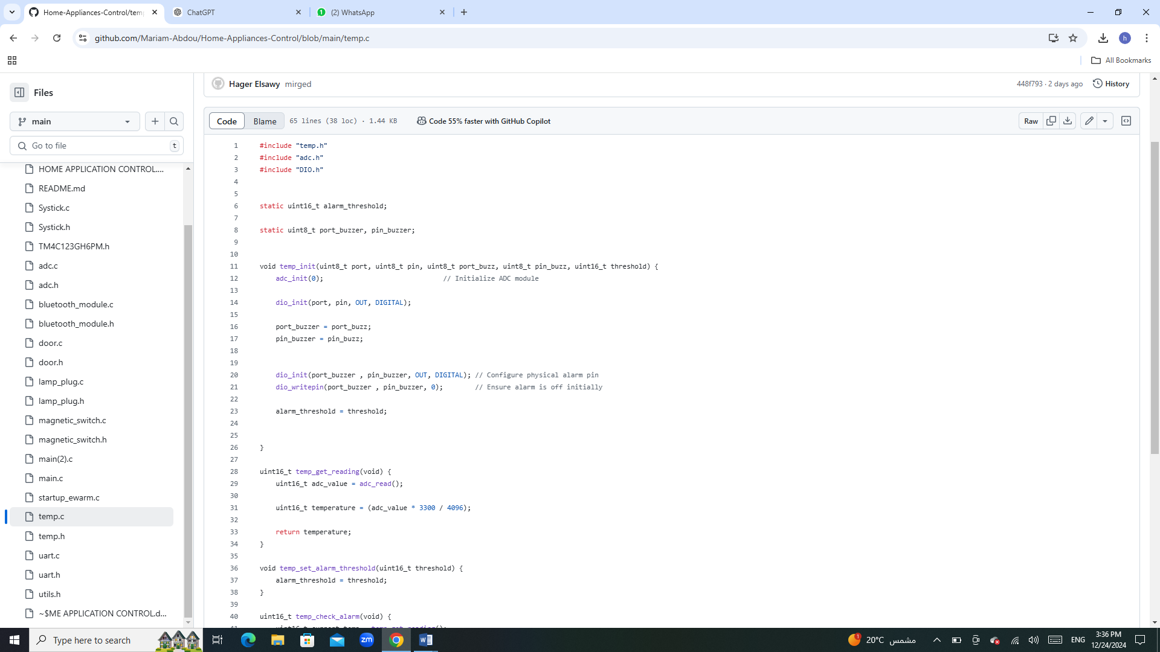

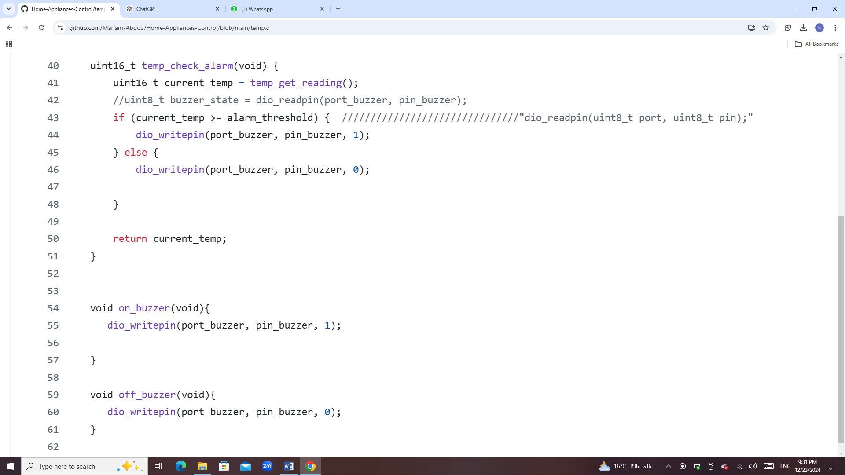

**Key Features:**

- The temp_get_reading function reads the ADC (Analog-to-Digital Converter) value, converts it to a temperature value using a scaling factor for a 12-bit ADC (0–4096 range), and returns the temperature.

- The temp_set_alarm_threshold function allows dynamic configuration of the alarm temperature threshold.

- The temp_init function initializes the temperature module, ADC, and a buzzer output pin. This setup includes ensuring the alarm buzzer is off at startup.

- Handles pin assignments for ADC input and buzzer output to ensure modular and reusable code for different hardware configurations.

## Hardware Abstraction Layer (HAL)

### ADC Implementation:

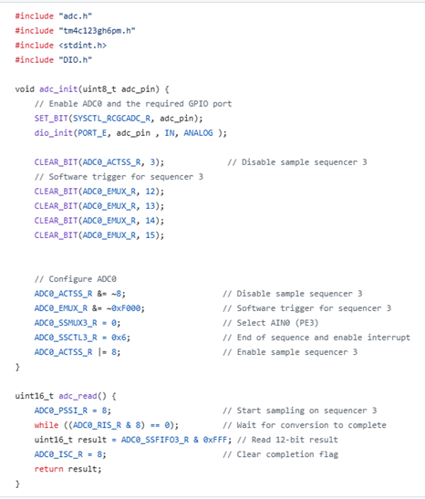

**Key Features:**

- Configures the GPIO pin as an analog input.

- Sets up ADC sequencer 3 for single-sample conversion using a software trigger.

- Starts a conversion on sequencer 3.

- Waits for the conversion to complete and returns the 12-bit result.